|  |  |
| --- | --- |
|  | **2017** |
|  | South metropolitan Tafe, Fremantle |

|  |  |
| --- | --- |
| **[Group Progress report]** | |
|  |

## TABLE OF CONTENTS

* Introduction
* Planning - (Gnatt Chart, Time line,)
* Virtualization (auto CAD, design from everyone, drawings etc)
* Calculations (ball screw, forces, model selection)
* Design (support for ball screw/ motor)
* Discussion (where are we now, what have we done)

Introduction

The objective of this report is to inform and update our lecturer on how our project of converting and *Old Manual Lathe in to CNC lathe* is going.

Our primary goal for the Semester 1 was to automate a ***Colchester Student 1800 Lathe*** that was originally completely mechanical. To complete this we decided that it was best to separate the work load.

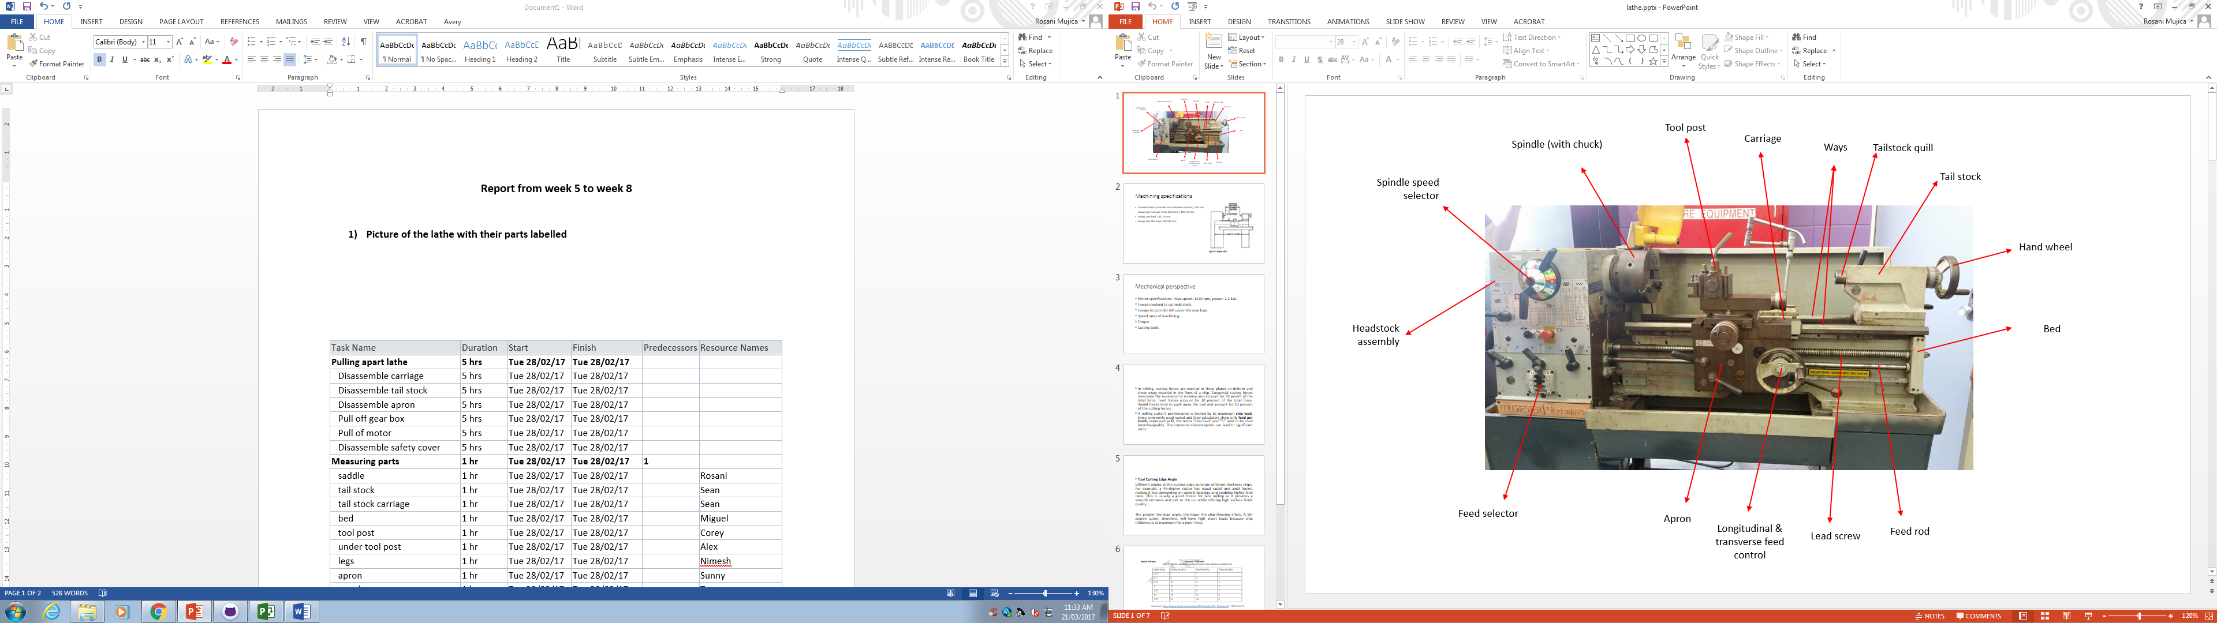Planning

Virtualization

3D auto cad of the cross slide that sit atop the saddle

3D auto cad of the Tool post

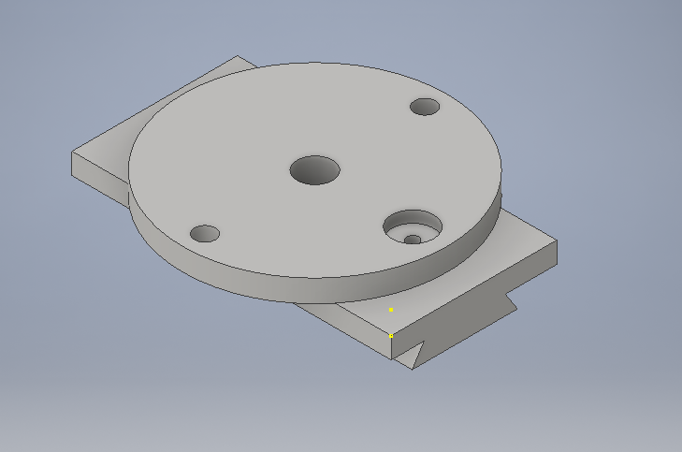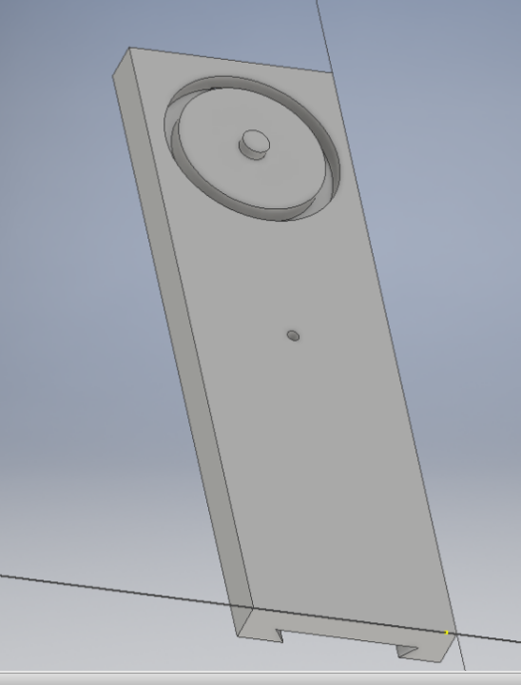

3D auto cad of the Tool post Bottom Carriage

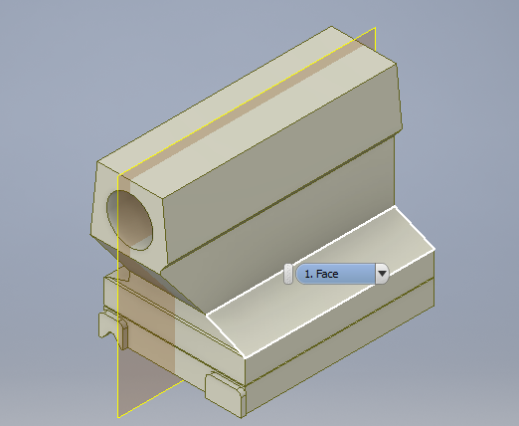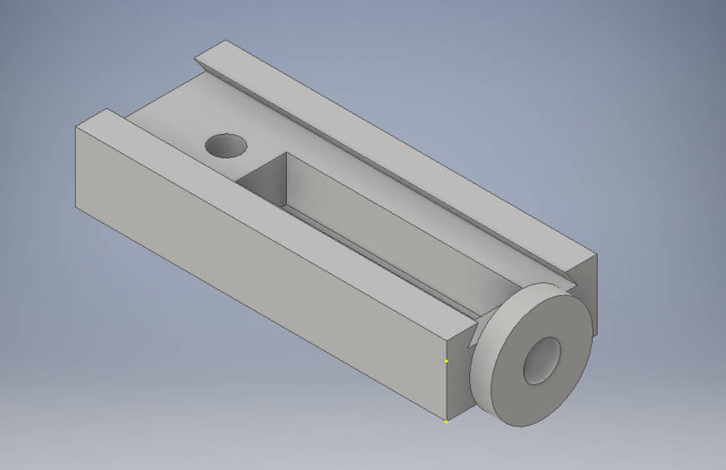

3D auto cad Tail Stock

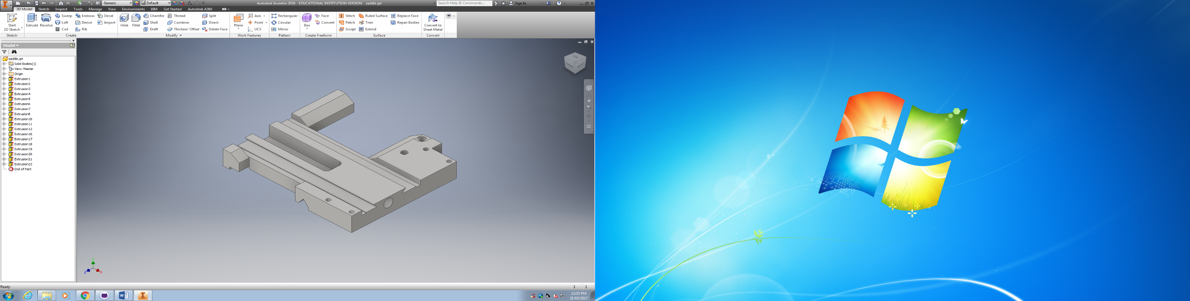

Calculations

Calculate torques and forces exerted by the lathe to be able to select both motors and ball screws.

Initial stablished parameters:

|  |  |  |
| --- | --- | --- |
| Predominantly material for workpiece | High Carbon Steel | N/A |
| Depth of cut (max) | 6 | mm |
| Feed rate (max) | 0.5 | mm/rev |
| Chuck angular velocity (max) | 22 - 1800 | RPM |
| Coefficient of friction metal-metal | 0.16 [1] | N/A |
| Z-axis weight | 50 | Kg |
| X-axis weight | 25 | Kg |
| Manual angular velocity | 120 | RPM |
| Lead angle accuracy | 0.05 | mm |
| Bl salcrew length to be used for the Z-axis | 1100 | mm |

CNC lathe is required to be driven by ball screws and servo motors for their lowest factors of frictions and accuracy respectively. Therefore all following calculations are aimed at selecting a ball screw and a servo motor which can overcome torque, velocity and forces developed by the lathe.

For cutting force calculation:

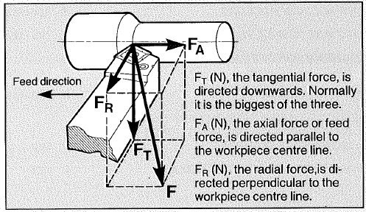

The approximate relationship of these components to each other is: $F_{T}:F_{A}:F_{R}=4:2:1$

Tangential cutting force ($F_{t}$) may be determined by:

$$F_{T}(N)=k_{s}×a×s$$

Where $k_{s}$ = specific cutting force (N/mm2)

a = depth of cut (mm)

s = feed (mm/rev)

As $k_{s}$ = 2300 N/mm2 for a workpiece of high carbon steel, it need to be corrected by three (3) factors which are insert geometry, entering angle of the tool and the feed rate chosen

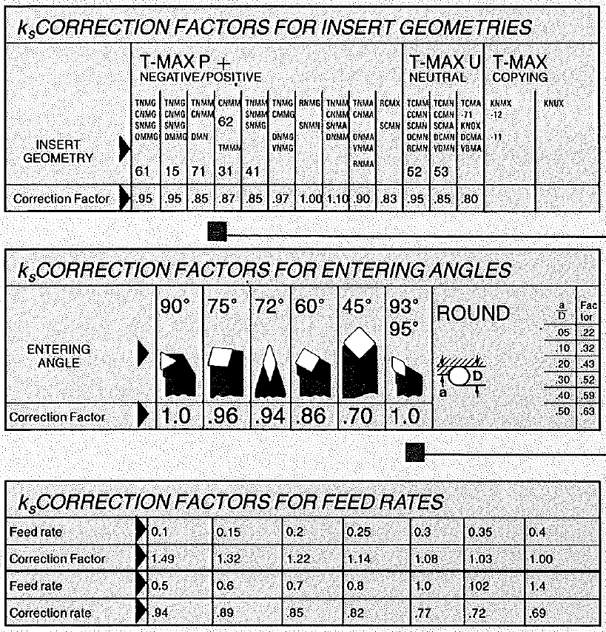

Researched ball screws, the formula need and using this calculated the ball screws needed for our lathe

$$Lead=\frac{Chuck angular velocity \left(RPM\right)×Feed rate \left(\frac{mm}{rev}\right)}{Manual angular velocity \left(RPM\right)}$$

$$T_{ball screw}=\frac{F_{mot}×Lead}{2π×η_{ball screw}×1000}$$

With these two formulas and also the breakdown of our forces and determining the cutting forces (produced by Miguel) we were able to obtain the toque on the ball screws

For the z-axis or The Apron we got a total force of **4632.5N**

$$F_{mot}=F_{F}+F_{A}=1182.5N+3450 N=4632.5N$$

Then using the above ball screw formula we get **8.2Nm**

And apply the safety factor we obtain the final **10.9Nm**

**Repeating this method for the x-axis or tool post**

We get $2868.2N$ for total collective force which makes our ball screw torques **5.1Nm** which makes it **6.8Nm** with a safety factor.

Design

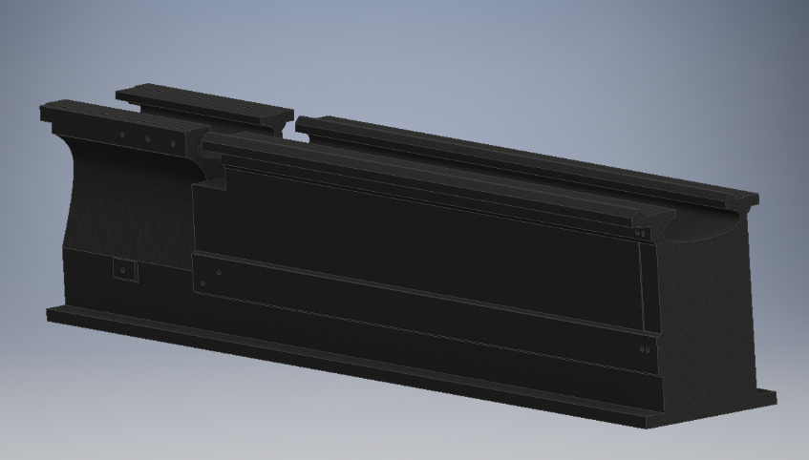

* Creation of holes to allocate motor and ball screw supports.
* Determine and specify the exact dimension and position of a zone to be grinded.
* 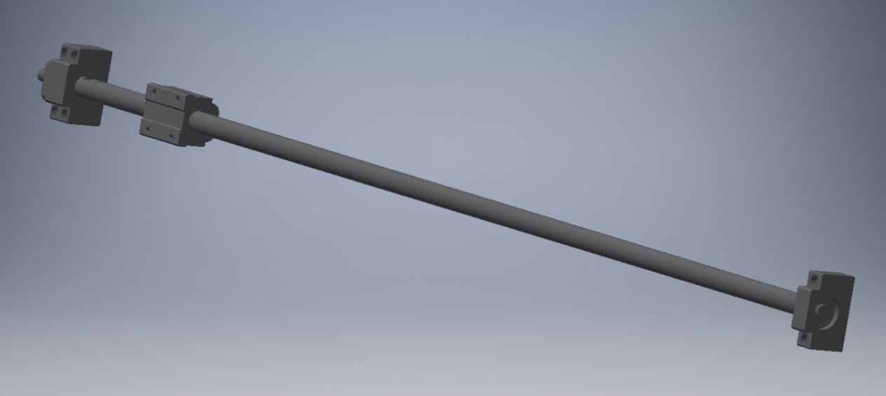Minor general dimension changes.

Support for the motor and ball screw

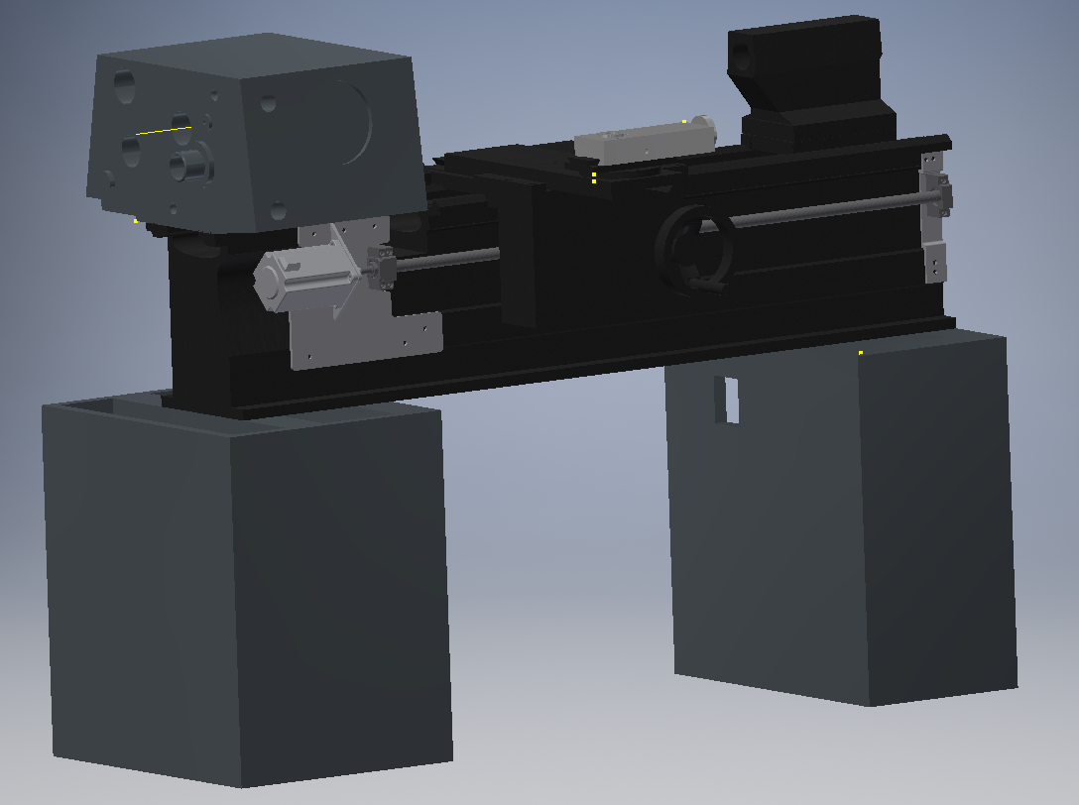

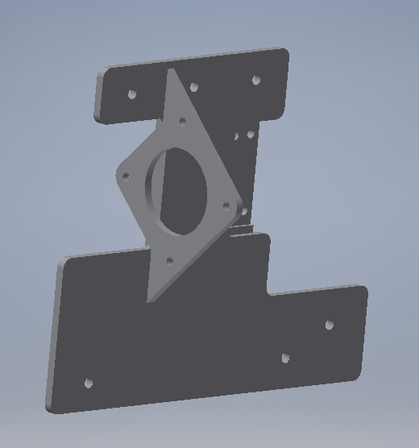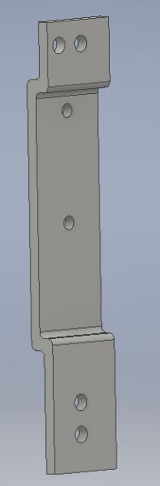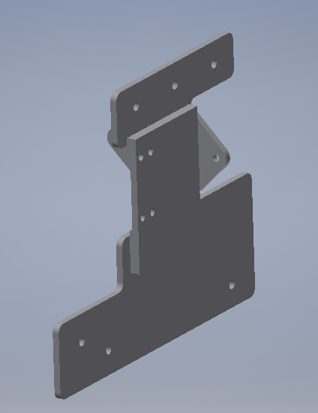

Manufacturing Drawings for the Supports

